# Getting to know Coordinates

## Part 1 - Coordinates

Start this activity using the [Peabody test](https://snap.berkeley.edu/snap/snap.html#present:Username=aspiece%40gmail.com&ProjectName=PeabodyTest).

* Open the link above.
* Click on Peabody to start the test.
* Answer his question in the textbox.
* You should answer at least 10 of his questions.

## Part 2 - Plot a drawing using a template

Using the [template](https://snap.berkeley.edu/snap/snap.html#present:Username=aspiece%40gmail.com&ProjectName=Snap%20Coordinate%20System%20Intro) from the classroom activity, create a drawing that has at least 10 coordinates. Save the drawing in Snap! and submit the URL to your teacher.

* Reminder: Don’t forget to log into Snap!

Here is an example with 8 coordinates:

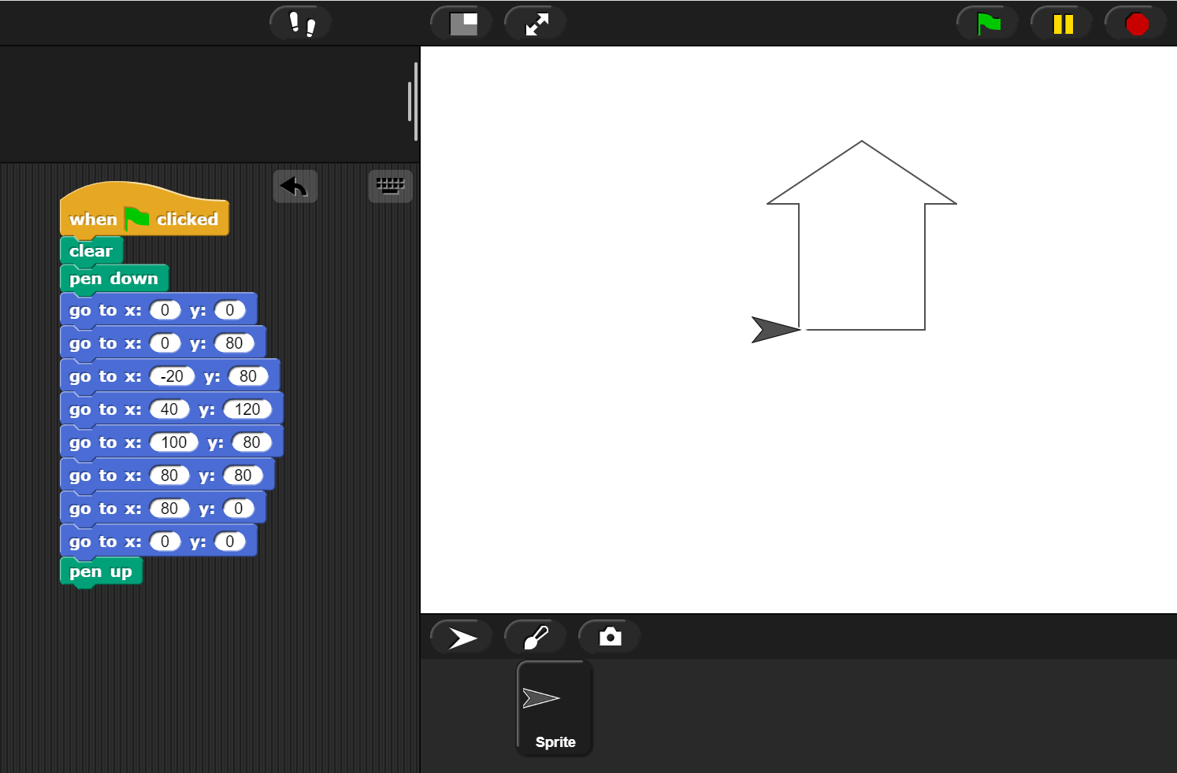

Snap coordinate example

## Grading scheme/rubric

| **Lab 0.5 criteria** | Points |
| --- | --- |
| **Part 1** |  |
| Participated in the Peabody test | 0.5 points |
| **Part 2** |  |
| Saves project | 0.25 points |
| Shares link with teacher | 0.25 points |
| Drawing contains at least 10 coordinates | 0.5 points |
| Drawing completeness (Resembles something recognizable) | 0.5 points |
| **PROJECT TOTAL** | **2 points** |